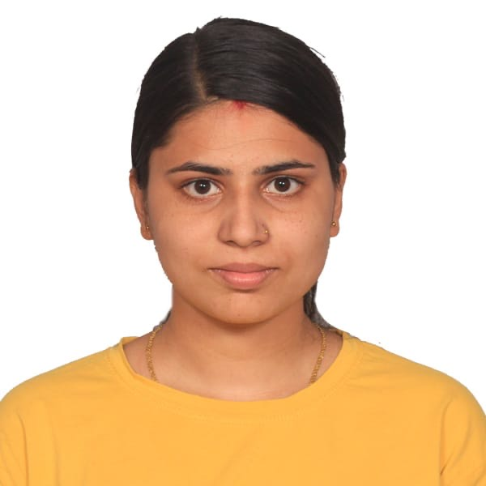
Shashi Kala Mishra


I am a talented, ambitious, and hardworking individual, with broad skills and experience as an age care worker. Furthermore, I am adept at handling multiple tasks daily competently, and at working well under pressure. A key strength is communication; building strong relationships with people to deliver the best results.

shashimishra0143@gmail.com
(+61) 0451 204 464

- 24, 36-38 Addlestone rd., Merrylands, Australia

EDUCATION

- Certificate III in Individual Support (Ageing and Disability) - Encourage Training College (ETC), Auburn, NSW, Australia (2023)
- Bachelor of Microbiology, Balkumari College, Chitwan, Nepal.
- High School Diploma in Science - New Capital College, Chitwan, Nepal.

WORK EXPERIENCE

• Fairfield Aged Care Home (Hall & Prior), Fairfield, Sydney (120-hour placement)
• Assisting patients with activities of daily living such as showering, bathing, dressing, grooming, and toileting.
• Serving meals to patients then monitoring their eating habits and feeding them if necessary and providing meal supplements as needed.
• Keeping patients’ rooms and equipment clean, neat and orderly.
• Observing residents' health concerns and reporting abnormalities to the Registered Nurse.


REFERENCES

Priyanka Bhatta
Bhattapriyanka151@gmail.com
0426662026
Castle Hill AngliCare

Sadhana Sharma
0414172442
Ssadhana729@gmail.com
Just better care

SKILLS

Cleaning First aid Team work Hard working

Management Problem solving Punctual

ORGANIZATIONS

Fairfield Aged Care Home (Hall & Prior)

CERTIFICATES

Certificate III in Individual Support (Ageing and Disability)

First Aid and CPR Certification - 2023

Police check

NDISWC working check

International Driving License

LANGUAGES

English Nepali

Full Professional Proficiency Full Professional Proficiency

Hindi

Professional Working Proficiency

INTERESTS

Music Trekking Travelling Cooking


Outdoor Activities

