SHARNAI
MCKEE
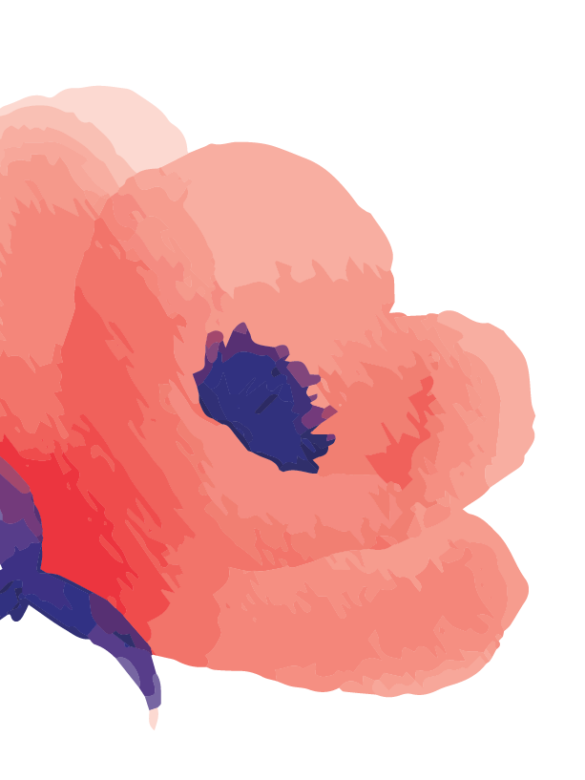 |  |  | Experience  September 2016–2021  Service Assistant • Hat Head Top Shop  Duties include cash handling, register operation, EFTPOS operation, and customer service, cooking of takeaway food, stock replenishment, mentoring and training new staff and cleaning.  December 2016–Current  Cleaner • Jolene’s cleaning services  Duties include vacuuming, cleaning kitchens, making beds, and changing over gas bottles.  october 2021–Current  Bartender/Waitress • Kempsey Macleay RSL  Duties include cash handling, RSA, RCG, customer service, training staff, waitressing, bartending  October 2024- current  AIN • Kempsey District Hospital  Duties include observing and reporting any changes in a patient's condition, maintaining hygiene, and assisting with simple wound care.  References  Helen and Tanya Slocombe  Hat Head Top Shop  (02) 6567 7555  Jolene Beaton  jolene’s cleaning services  0435 865 363  Bianca Hopper  Kempsey Macleay RSL  0431 746 308  Kate Martin  Kempsey District Hospital IPU NUM  Kattherine.martin@health.nsw.gov.au
10 Lindsay Place

West Kempsey , NSW, 2440
0402 130 527

sharnaimckee12@gmail.com



Page 2

SHARNAI
MCKEE

Education
- 2018 – Statement of Participation “Glam it Up” ----- Hairdressing and Beauty Make-Up – Kempsey ------ TAFE
- 2018 – Teen Mental Health First Aid Course
- 2020 – First Aid Certificate 10252201-6463433
- 2020 – Graduated Year 12, Melville High School
- 2020 – Certificate “Responsible Conduct of Gambling”
- 2020 – Certificate “Responsible Service of Alcohol”
- 2020 – Certificate II in Hospitality
- 2021 – Southern Cross University, Bachelor of
Nursing

Summary
I would like to gain employment as an AIN in the nursing home as I am currently in my second year of university studying a Bachelor of Nursing at Southern Cross University in Coffs Harbour. It would mean a lot to me to be able to work as an AIN to gain more experience as I am still studying and give me the experience I need for when I finish my degree. If I am lucky enough to be given the opportunity I will not let you down, I am a very hard worker a caring person and I’m always looking out for people when they need.

10 lindsay place

west kempsey 2440
0402 130 527

sharnaimckee12@gmail.com

Page 1

