ALEJANDRO C. ALVARRO JR.
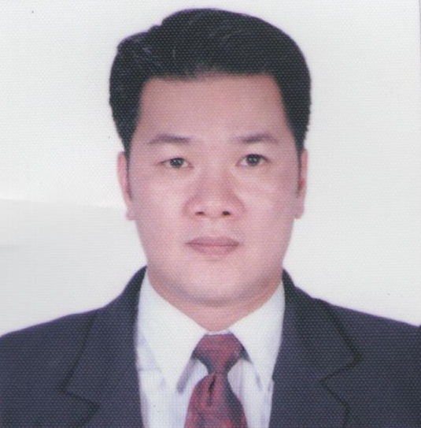
Address: 189 Lane Cove Road,
North Ryde NSW 2113
Mobile Number: 0423919025
E-mail address: aalvarro@yahoo.com

EDUCATIONAL BACKGROUND

Elementary Year (From – To)
School: San Agustin Elem. School 1984 – 1986
Address: San Agustin Novaliches Quezon City, Phil.

Secondary
School: Novaliches High School 1986 - 1990
Address: Novaliches Quezon City, Phil.

College
Course: Bachelor of Science Major in Biology 1990 – 1999
School: Far Eastern University
Address: Morayta Manila, Philippines

Course : Certificate IV Ageing Support Oct 16-2023 Up to Present
School: Australia College of. Community and health Services
Address: unit 107 Cowper St. Parramatta NSW 2150

EMPLOYMENT HISTORY

Position : Caregiver / Health Care
Address: 3333 Apitong St.United Parañaque Subdivision II
Pastient Name: Roberto Cordero
Pastient #: 09279600679
Date: 2011-2014
- Assist clients with certain physical activities, such as walking, getting into or out of bed, dressing and climbing stairs.
- Provide clients with assistance as needed, including helping with bathing and other personal hygiene activities.
- Monitor aspects of the client’s health under the direction of a registered nurse, doctor or other approved physician, including taking vital signs and administering medication.
- Advise clients and families on alterations to the house or living environment for enhanced health, including nutrition, personal hygiene and sanitary living conditions

Position: Caregiver / Health Care
Address: Tampico Tarlac City Philippines
Pastient Name: Rule Cordero
Patient #: 09657613589
Date: 2015-2022

- Collaborated with medical team to develop customized care plans for patients with chronic illnesses.
- Administered medications accurately and assisted with medical procedures under the supervision of healthcare professionals.
- Provided emotional support and companionship to individuals, improving their mental well-being.
- Assisted in rehabilitative exercises resulting in increased strength and range of motion for patients.
- Documented patient progress, maintaining accurate records for healthcare providers.

PERSONAL BACKGROUND

Born on June 9, 1972 in Manila, Philippines. Fluent in English and Filipino. Knowledgeable in Microsoft programs. Interested in Tennis. Has excellent interpersonal skills and commercial awareness. Confident, responsible and determined.

CHARACTER REFERENCES:

Mr. Antonio Lopa
CEO President
Masco Auto Sales Incorporated Inc.
16th flr. Tower 1 Exchange Plaza Ayala Ave., Makati City
Phone No. (63) 2 848-5418

Mr. Dennis De Leon
2nd Mate / Instructor
ISNTC Internship Navigation Training Center
2nd Flr. CRI Building 665 Pres. Quirino Ave. Malate Manila
Cel# (63) 9202165620

Mr. Reynaldo Garcia
12 Clancey Avenue, Glendening New South Wales, Australia
CP# +61425241080 / Tel. +61296257878

