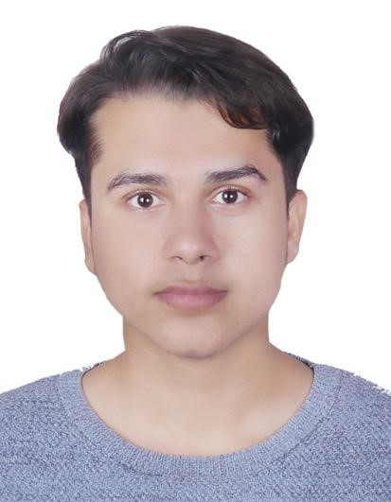
333 Canterbury road,
Canterbury, 2193
0420531233
lomasghimire2@gmail.com

LOMAS GHIMIRE, MR
Hardworking and benevolent Nursing student offering work experience In residential aged care and home care.
Would describe myself as passionate, caring, good listener and always keen to learn.
Meticulous and detail-oriented with excellent observational, organizational, communicational and social skills with a positive attitude and a will to learn and adapt in a fast-paced world.

EDUCATION:
-Global educational institute, Campsie, NSW
Certificate three in individual support (Aging and disability)
-Australian catholic university, north Sydney, first year nursing student
-Trinity international college, Kathmandu Nepal, high school graduate ,2019
-Everest English school, Biratnagar Nepal, middle school graduate, 2017

Experience
- 120 hours work placement as AIN at Bayswater Gardens nursing home, Abbotsford, NSW 23rd May 2022- 15th June 2022
- AIN at calvary Corymbia
Belrose, NSW (1st august- current day), reference- Chris, senior admin , 0450 340 721

- Housekeeping attendant at Meriton suites, Campbell Street, Haymarket. 5th march - 30th july
Reference- Stephen tan, supervisor, +610452621689

