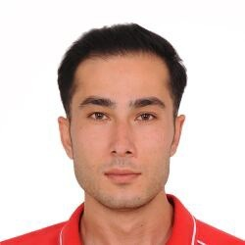 Mehmet Ali Tiryaki

Personal
Name | Mehmet Ali Tiryaki
Address | 75 school rd Maroochydore Queensland,Brisbane
Phone number | 0432701643
Email | tiryaki.6027@gmail.com
Date of birth | 19-01-1998
Place of birth | Turkey
Gender | Male
Nationality | Turkey
Marital status | Single
Driving licence | A,B
Resume objective
-
Work experience
Intensive Care Nurse ^{Sep 2021 - Aug 2022}
NCR International Hospital, Turkey
Hi Iʼm Ali from Turkey. I worked as intensive care nurse. I worked as an emergency nurse and pediatrician nurse. I will be able to every department.I have too many experience at at the aged carers.Im really keen on the work at the aged carers.
Blood Donation Specialist and Flebotomist Jan 2022 - Apr 2023
Aegean Blood Donation center, Turkey
Hi Iʼm Ali from I have worked as a blood donor recruitment specialist and as a fleet tommy nurse. I received all the training about the safety blood supply program. I'm ready to do my best.
Asistant in Nursing
St Mary’s Aged Care Feb 2024-Jun 2024
Personal Care Worker
Arcare Aged Care Jul 2023-Nov 2023
Personal Care Assistant
Ozcare Aged Care Apr 2023-JunApr 2023
Nursing In Asistant
Currently Lighthouse Recruitment

Education and Qualifications
07.06.2021 Sep 2017 - Jun 2021
Gaziosmanpaşa University Healthy Science Faculty For Nursing(Bachelor Degree), Turkey
Interests
Gym,Football
References
Veronique ^{UK Med}
+44 7734 240366

Skills
-Nurse Management
-Patient Care
-Home Care
-Medication Administration
-Vital Signs
-Dementia Care
-Alzheimer’s Care
-Critical Care Experience

