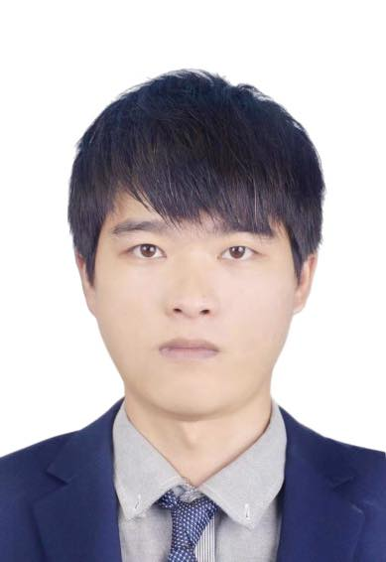 |  | WENTAO  FAN
contact  3/122 Todman Ave, Kensington NSW 2033  Phone:  61422773212  Email：  ycdf120206@outlook.jp  hobbies  Photography  Reading  mountain climbing |  | Education  Nanjing University Bachelor  Applied Psychology  22 Hankou Road, Gulou District, Nanjing, Jiangsu, Graduated.  Sunshine Coast International College  16/01/2023--NOW  Experience  DA BEI NONG GROUP Office Manager  17/09/2019-28/01/2022  Prepare and organize meetings, and inspect and supervise the implementation of decisions made at meetings;  Employee growth (EAP) psychological counseling and group therapy;  Finance, cashier, procurement, warehouse, personnel scheduling, employee performance salary review;  Preparation of enterprise brochures, employee manuals, plans, etc;  Communication and coordination among government, partners, customers and various departments.  MEIDEN SINGAPORE PTE.LTD Operator  28/01/2022 – 26/10/2022  Arrangement and entry of production data

