CURRICULAM VITAE

)
Shivangi Sharma (Shivi) Address: 1104/15 Village Boulevard, Southport, 4215

MOB- +61404227307,
shivicampy@gmail.com

CAREER OBJECTIVE

A complete dedication to my noble, profession of nursing in any kind of environment with endurance regardless of all hurdles that come my way I would like to have success my PRECIS way through.

- Working as an AIN form Jan 2023 till now.
- Overseas RN, worked as a scrub nurse for the last 7.5 years at the cardiac Cath lab department.
- Worked with Sri Satyasai Sanjeevni Hospital Raipur from Oct 2017 to June 2022.
- 3 years’ experience with Fortis Escorts Hospital (June 2014- September 2017)
- Currently pursuing Community services from Alana Kaye College, Southport.
- Currently holding- NDIS Card, Blue card, Photo ID card, First aid and CPR certificate, and Overseas Driving license.

- Quality control and record keeping as per NABH and with well-known multi-specialty hospital.
- Team player with strong analytical and organizational.
- Possess sound knowledge and comprehensive understanding of medical equipment skills.

ACCADMICS CREDENTIALS

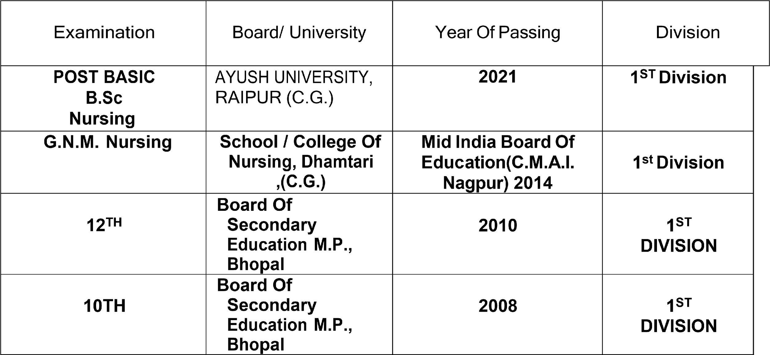

PROFEESSIONAL REGISTRATION

ORGANISATION | MEMBERSHIP STATUS | MEMBERSHIP NO. | DATE OF EXPIRY
C.G NURSING  COUNCIL P.B.B.Sc NURSING | REGISTERED NURSE | II-1136 | NA
C.G NURSING  COUNCIL  GNM | REGISTERED NURSE | IV-4237 | 23.09.2024

PERSONAL DOSSIER
 | Date of birth | : | 07/08/1991
 | Gender | : | Female
 | Marital Status | : | Single
 | Nationality | : | Indian
 | Linguistic Abilities | : | English
DECLARATION | &Hindi Passport | : | U8630844
I hereby declare that the above-mentioned details are correct and true to best of my knowledge and belief.

Referees available on request.

