 |  |  | Yen Kumari Thakuri
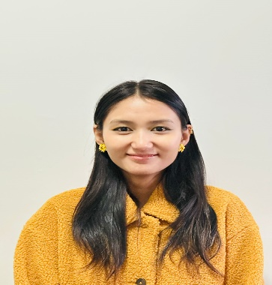  Contact  0410983689   thakuriaasheeka@gmail.com  3 Campbell Street Parramatta, NSW, 32150  Certificates  - Certificate IV in Ageing Support  - First Aid and CPR  - NDIS Worker Orientation  - Current Vaccination  - Police Check  - National Hand Hygiene Initiative  - Basic Life Support  Professional Skills  - Ability to work successfully with others on collaborative projects and efforts  - Productive worker with a solid work ethic to exert optimal effort in completing tasks  - Skills for patients’ care  - Capable of handling patients  - Honest, sincere, hardworking, polite, and dedicated  - Competency in MS-Word, Excel, PowerPoint |  | Education  2018 – 2020 Bright Future College  +2, Management, Major in Business, Kathmandu, Nepal  2023-2024 Aapoly College  Diploma in Leadership and Management, NSW, Sydney  2024 – Current Aapoly college  Bachelor’s in leadership and management, NSW, Sydney  Experience  Bupa Aged Care Dural, NSW (Finished Placement on May 2024)  - Helping resident with Feeding, Showering, and changing pads  - Assisting with personal hygiene  - Helping with Bowl Movement  - Ensuring their Safety and maintaining their Dignity  - Providing mobility and emotional support  - Ensuring Residents are eating and drinking regularly at appropriate times.  Woolworths Group Limited, Chatswood East, NSW, Bakery Team member  - Working cooperatively in a team with other bakery staff  - Delivering Quality and fresh baked goods  - Helping to the customers  - Filling and maintaining the stocks  - Stocking and Merchandising  Support Foundation ( 2 to 3 weeks Experience)  - Providing emotional support  - Helping clients with activities of daily living  - Maintaning their records and help them in participate in social activities  - Ensuring their Safety and maintaining their Dignity  - Health support  References  [Available upon request]

