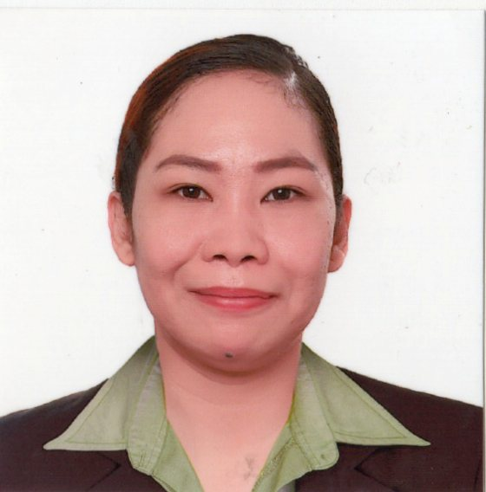
JERAH SYRREN ARMADA
#19 Saint Aimon st. Dreamland Subd.
Balante-Banaba San Mateo Rizal
Cellphone no: 09162886205
e-mail: juranearmada@gmail.com

OBJECTIVE:

Qualified Health Care Provider looking to be part of a team of skilled nursing assistant which care for individuals who are in need of competent health care.

Skills and Qualifications:

- Graduated with recognized talents in performing patient care.
- Optimum bedside manners skills and rapport in dealling with co-workers and patients.
- Demonstrated knack for learning new skills quickly and easily
- Strong abilities in multi-tasking
- Able to excel in team encironment.

EDUCATION:

2001 – 2005 SECONDARY
Hillsdale Academy
Km. Quirino Highway SJDM Bulacan

2005 – 2006 TERTIARY
BS Tourism
Our Lady of Fatima University
Quezon City

2007 – 2009 BS Tourism
Lyceum of the Philippines University
Manila

2016 Personal Care Aide/ Caregiver
Escuela Teknika Vocational Skills Education
SJDM Bulacan

CERTIFICATES AND TRAINING:

2016 TERSDA Certificate NCII
Health Care Services

2016 Rogaciano M. Memorial hospital
Certificate of Completion 208 hours
Related Learning Experience

2016 Rave Manpower Agency
Basic Nursing Skills Training
(NGT feeding and insertion, Catheterization management, Tracheostomy care, Nebulization, Oxygenation and Bed making)

2022 Basic Life Support
Commonwealth Hospital and Medical Center

WORK HISTORY:

2016 Personal Care Aide (Diabetic Patient)
Mr. Nelson D. Chua
82 North Harbor Highway Navotas City

2016 Rave Manpower Agency
Nursing Aide
Commonwealth Hospital and Medical Center

2018 – 2022 Nursing Aide
Emergency room
Commonwealth Hospital and Medical Center

REFERENCES:

Atty. Nicolas B. Lutero III, CESOIII
Director IV
DOH
Health Facility & Services Regulatory Bureau
(632) 651-7800

