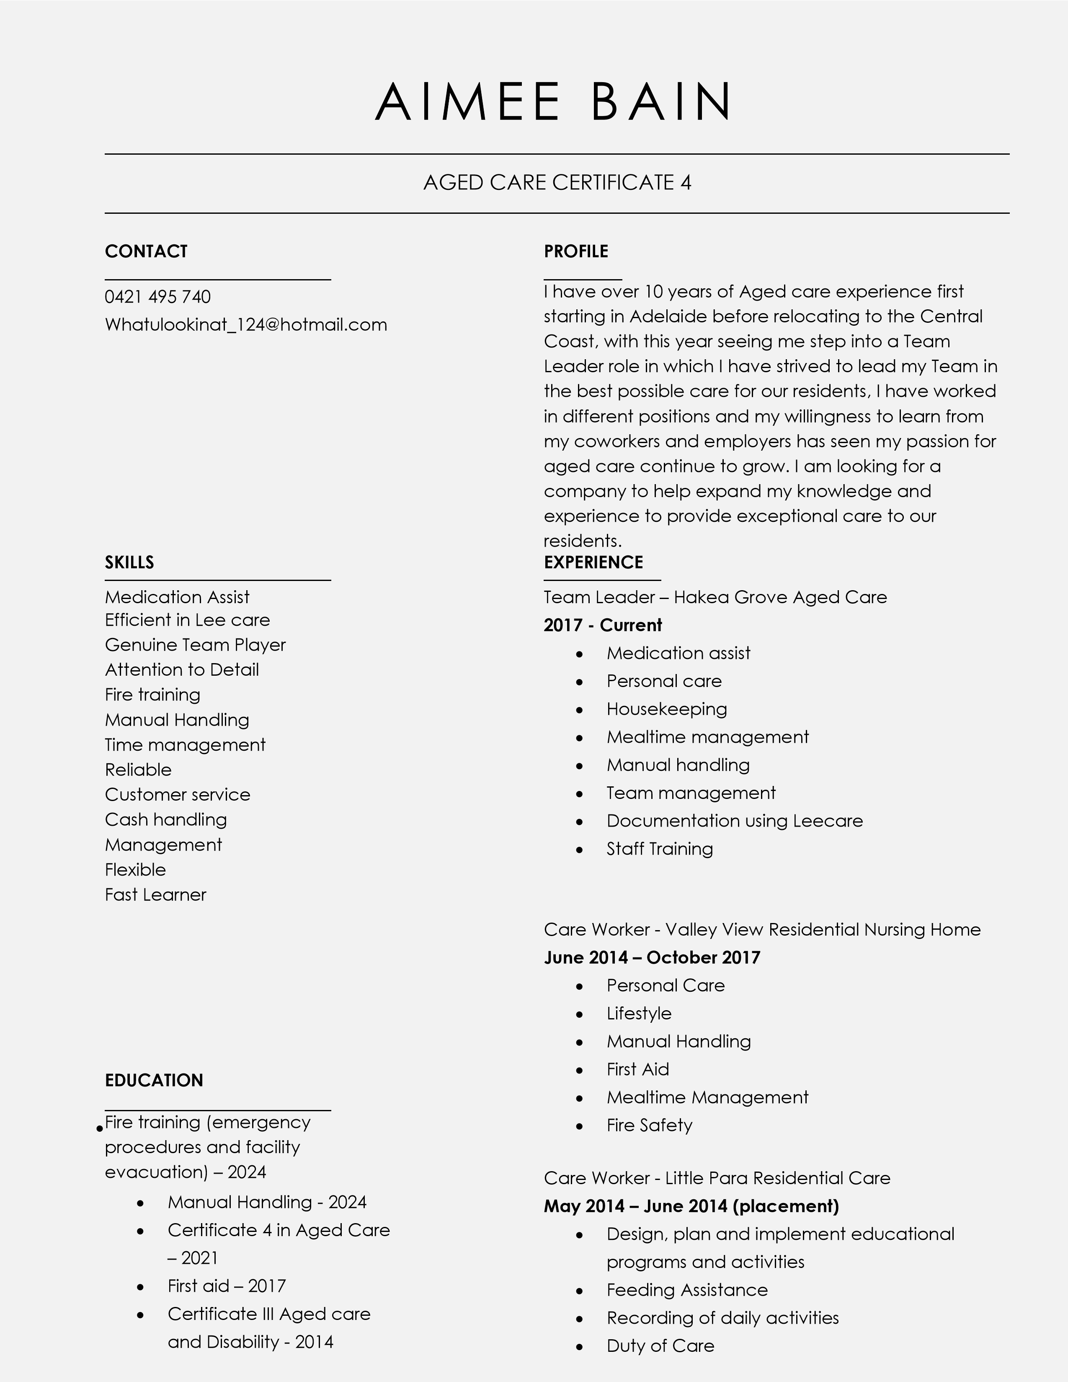

- Certificate III in Children’s Services – 2008
- Certificate II in Retail –
2006
- Year 10 Certificate – 2005

References
- Meg Robertson, Head of clinical care
- Hakea grove 0400 413 565

- Jo Heslin, CEO Hakea grove
- 0435 785 376

- Personal Care
- Mealtime Management
- Manual Handling
- Teamwork

Casual - Hope Valley Childcare Centre

Jan 2013 – March 2013
- Duty of Care
- Personal Care
- Mealtime Management
- Manual Handling
- Teamwork

Flower Buncher -Cottage Flowers

Feb 2009 – March 2013
- Packing orders
- Dispatching orders
- Barcoding products
- Housekeeping
- Flower arrangement

Childcare Assistant -ABC Early Learning Centre

July 2007 – Feb 2009
- Design, plan and implement educational programs and activities
- Housekeeping
- Ability to provide affection, security and comfort
- Manual handling
- Child supervision
- Feeding Assistance
- Liaising with parents
- Recording of daily activities

Cashier – Drakes Supermarket

Nov 2006 – Feb 2007
- Customer Service
- Stock take
- Cash Handling
- Housekeeping

