Sujata Tamang
15 Burwood Road ,Burwood, NSW 2134
tsuju341@gmail.com
Contact no-0451601997
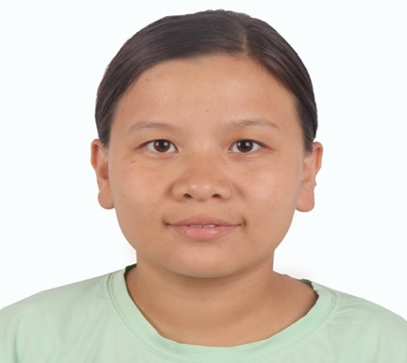
:

Personal profile statement

I would like to describe myself as an honest and hardworking person, always eager to try new things in my life with high dedication. I also have the quality to work individually as well as working with team members. I am good at interpersonal skills and seeking for doing good work to increase my knowledge and experience in the field of public health and Age care facility.

Experience (Workshop/Seminar/ Training)
- Worked as a disability support worker in the home including Shower, making lunch, doing household chores, giving medicine, grooming, and tidying for 2 months in Adelaide
- Worked as a volunteer in Pashupati Old Aged home for 6 months.
- Participated in a two-day workshop on “Sustainable Development Goals and Youth Leadership” in collaboration with Kantipur City College, Kathmandu.
- Attended Seminar on Mental Health program in Om Health Campus
- Attended 5-day Transformation Divine Principle Seminar
- Active Volunteering in the Art competition organized by Lions/Leo Club held at Brooklyn Intn’l college,Sukedhara
- Organized and participated in the health teaching at Mahila Chetana School, Kathmandu, Nepal which serves education for old women
- Conducted Community Health Diagnosis for a month at Deurali, Kaski, Nepal
- Worked under Health Office, to learn District Health Management in Lamjhung for a month
- Conducted School Health Program on Substance Abuse on Shree Biswa Shanti Secondary Level school at Deurali, Kaski.
- Conducted School Health Program on Oral Health at Shree Biswa Shanti Primary level school at Deurali, Kaski
- Organized and conducted Anthropometric measurement Training in 2019 at Om Health Campus.
- Done research on Knowledge, Attitude, and Practice towards Covid-19 among general population in Tadi-3 rural municipality Nuwakot.
- Volunteered in CICT (Case Investigation and Contact Tracing) through a telephone survey in Karnali province organized by Dhulikhel Hospital in collaboration with Yale University.

Education and certificate

- Bachelor’s degree in public health

Visa Status
- Student visa sub-class 500

Professional work experience
- Certificate IV Aged care and Disability

Skills and Abilities
- Effective Team Player.
- Quick learner.
- Effective communication Skills.
- Enjoy working with people of diverse backgrounds, cultures and professional levels.

LANGUAGES
- Nepali ( Professional proficiency )
- English ( Professional working proficiency )

REFERENCES
Sarita Regmi
Registered Nurse
Ph no-0416104734

Heena Rajbanshi
Registered Nurse
SA Health
Ph no-0410627954

