RESUME

NAME:
Address: ANISHA RANA
Email: anisharana312@gmail.com
Mobile: 0414429463

Objective:

I am looking for a part time employment for the post of Assistant in Nursing. I wish to have my career which employs my skills and expertise fully to join the organization which values enthusiasm, professionalism, and commitment to perform significant responsibilities and opportunities.

Trainings:

· First Aid Training
· CPR Training

Certificates:

· Police certificate
· First Aid and CPR Certificate
· Certificate III Individual Support (Ageing/Disability)

Professional skills:

· Ability to work successfully with others on collaborative projects and efforts.
· Productive worker with solid work ethic to exert optimal effort in successfully completing tasks.
· Organized and effective communicator with the ability to learn quickly and develop expertise to produce efficient contributions to the organization
· Competency in Microsoft Word, Excel, PowerPoint, and Outlook environment.
· Honest, sincere, hardworking, polite, and dedicated.
· Capable of handling patients.
· Skills for patients’ care.
· Working within scope of practice.
· Performs own duty of care.

Experiences: 120 hour placement in St catherines seton community
web: 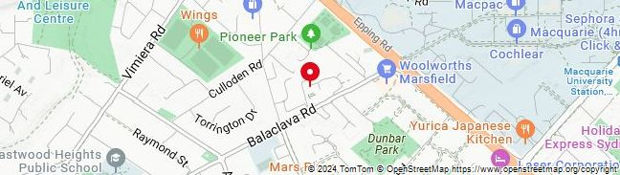
www.scacs.org.au

References:

Niranjan Prasai
Training Manager / Trainer
Oscars Training Centre
Ph. No: 0451995201
Email: prasainiranjan2014@gmail.com

